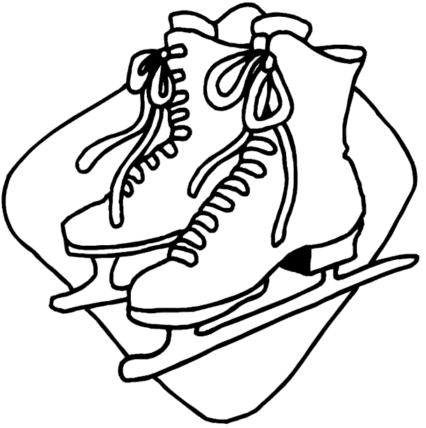
WOLFE ISLAND COMMUNITY CENTRE RECREATION COMMITTEE - WINTER PROGRAMMING 2023
SIGN UP WOLFE ISLAND TOWN HALL UNTIL NOVEMBER 30TH, 2022
REGISTRATION FOR EACH ACTIVITY IS $50.00
Learn to Skate:
Sundays: January 8th – February 19th
New Skater/Beginner (All Ages) @ 12:00 – 12:30 pm

Power Skating:
Tuesday: January 3rd – February 21st @ 7:00 pm – 8:00 pm
Thursday: January 5th – February 23rd @ 7:00 pm – 8:00 pm
Intermediate/Advanced skater, Ages 6+ Welcome to participate/pay for one or both sessions.

Hockey:
Fridays: January 7th – February 25th
Youth (Beginner-Novice) @ 5:30 pm – 6:30 pm
Youth (eligible – Atom-Bantam) @ 6:30 pm – 7:30 pm
Mixed Rec (eligible Midget+) @ 7:30 pm – 8:30 pm
Women’s (Time to be determined pending interests and enrollment)

Old Timers Hockey:
Tuesday: January 3rd – February 21st @ 3:00 pm – 4:00 pm
Thursday: January 5th – February 23rd @ 3:00 pm – 4:00 pm
Mandatory equipment includes helmet and gloves. Shin pads and elbow pads are highly recommended. Full hockey equipment is mandatory for youth programs and allowed for all programs. Hockey teams will be chosen based on sign up/payment on registration nights. We cannot guarantee teammate requests. Goalies at reduced rate.
Registration is open for ALL PROGRAMS @ the Township office on Wolfe Island during regular business hours before December 30, 2022
There will be no collections at the rink. Your name will only go on the list once you have paid in full. Any program may be cancelled due to low registration numbers.
No Pay at registration No Play! Cash, Debit, or a Cheque made out to Township of Frontenac Islands. A receipt will be provided.

Volunteers needed: Please sign up at Township office if you are interested in positions such as coordinator, timekeeper, referee, etc.

Any questions call or text Gary Greenwood 613-328-8327

